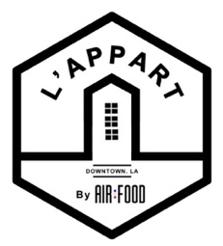
March 09TH 2022
Most of our veggies come from the DTLA farmers market

Small Plates
Baguette stuffed with garlic, parsley butter. 6
Mediterranean Olives, marinated in lemon. 6
Agour & Cantal Cheese, and it’s figs chutney. 10
Labneh, Smoked oil, sumac & toasted pita bread. 10
Sardines, with lemon butter, câpron and croutons. 11
Iberico Bellota Ham, served with Guerande butter. 12

Appetizers
Macaroni & Cheese, baked in a blue cheese sauce. 13*
Old Fashion Onion Soup, topped with grilled French Emmental cheese. 13/ Add Truffle +5*
Shallots Tatin, upside-down caramelized shallots & onion jam tarte. 15*
Burrata, with spinach, & grilled pine nuts. 15*
Escargots de Bourgogne, stuffed with garlic parsley butter and bread crumbs.
Per 6/14 Per 12/22

Entrees
Moules Marinière, (mussels) half size 16 / full size 24*
Stewed with onion, celery, white wine, parsley butter cream, served with French fries (full seize only).
Duck Confit, duck leg, served with a garlic Parsley butter mushroom fricassee & Marsala pepper sauce. 27
Souris D’agneau, lamb Shank, apricot juice, served with parsnip mousseline. 29
Risotto, cooked in an organic red miso and Portobello bouillon & sautéed King prawn. 30*
Line caught Sea Bass, baked with ratatouille, served with a tomatoe basil bouillon. 32*
Filet Mignon “Royal”, périgourdine sauce & frites. 35

Desserts
Crème Brulée (ask our server for the flavor of the week) 10
Tiramisu 10
Thin apple tarte, à la mode. (For 2) 16

automatic 20% gratuity for parties of 6 or more.
*vegetarian or can be made vegetarian.

